**Casa De Solana Bed & Breakfast**

**Old World Charm In The Heart Of St. Augustine**

Casa De Solana Bed and Breakfast is a lovely place for a romantic stay in St. Augustine, Florida. Our cozy guest rooms are close to many popular places like restaurants, galleries, museums, parks, Flagler College, sightseeing trains, and historic sites.

We have ten unique rooms and suites waiting for you. Each morning, you'll enjoy a tasty breakfast at the inn to get you ready for another amazing day on Florida's northeast coast.

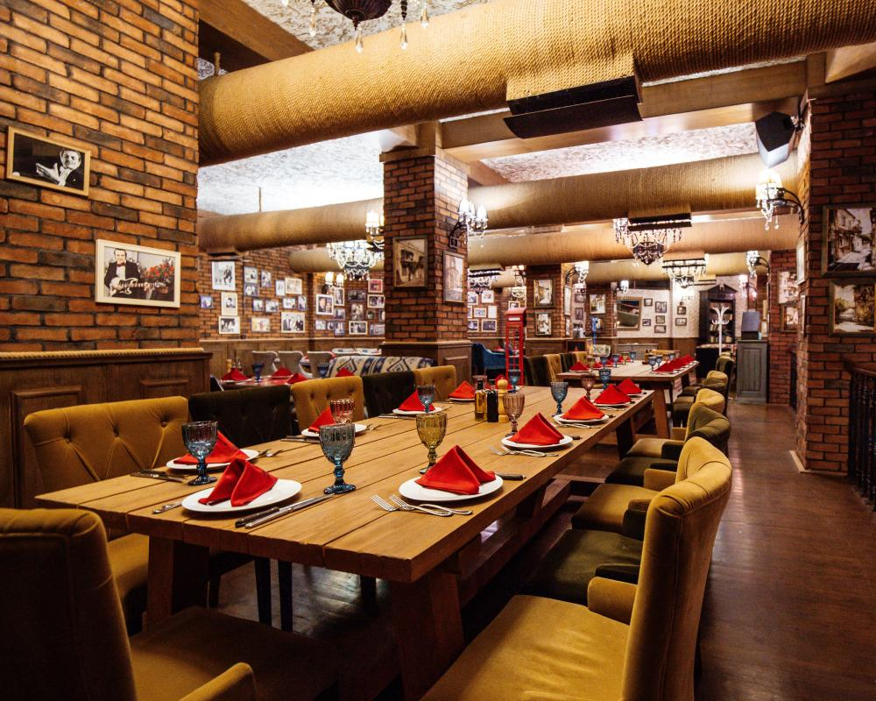

Our inn has a warm and welcoming atmosphere, making it perfect for romantic moments. We also love helping couples plan and celebrate intimate weddings or elopements on our grounds. We want your special day to be a beautiful experience that marks the start of your new life together.

**History Of Casa De Solana Bed And Breakfast**

Our inn is in the seventh-oldest house on the oldest street in St. Augustine. But don't be fooled by its age - [Casa de Solana Bed and Breakfast](https://www.casadesolana.com/) is a modern and welcoming place. With ten rooms, it has beautiful architecture and decor, and you'll be greeted by delicious smells from the kitchen.

The inn is named after its first owner, Don Manuel Lorenzo Solana, who was part of one of the first Spanish families in St. Augustine. At 23 years old, he was in the Spanish Army's Mounted Dragoons and stayed in the city after the British took over in 1763. He built a tabby house on the property and married Mary Mitchell, but their marriage wasn't recognized by the Catholic Church.

Solana later married Mary Mastres and had 11 more children. Even back then, the house was like a bed and breakfast, as the couple often offered hospitality to Native Americans, injured soldiers, and any traveler in need of a place to rest.

**Our Services**

**Wedding**

If you're planning a small wedding in northeastern Florida, consider [Casa de Solana Bed and Breakfast](https://www.casadesolana.com/) in historic St. Augustine. We happily welcome couples from near and far for their destination weddings, and we have wedding packages that suit different needs and budgets.



Our lovely inn and grounds provide a perfect setting for your special day, and we offer comfortable accommodations for your guests. The historic buildings and cobblestone streets around us also make fantastic backdrops for your wedding photos. In fact, St. Augustine was ranked in the top 10 for America's Happiest Seaside Towns in 2014 by Coastal Living Magazine.

**Elopement**

If you're not into formal weddings and prefer a relaxed and enjoyable exchange of vows, consider letting [Casa de Solana Bed and Breakfast](https://www.casadesolana.com/) host your elopement in Florida.



We have affordable packages for your ceremony, whether it's just the two of you (we can witness the vows in our beautiful courtyard, gardens, or inside the inn), or you can bring a couple of friends for a unique Elopement Cruise ceremony.

**Important notes for all packages:**

* Please book at least 48 hours in advance for all elopement packages.
* You need a valid Florida Marriage License to get married at the inn.
* A 50% non-refundable deposit is required when you book.

**Romantic Bed And Breakfast Extras**

Who says things can't be perfect? Experience romance at [Casa de Solana Bed and Breakfast!](https://www.casadesolana.com/) Our lovely inn is a great place for a relaxing vacation, and our affordable romantic extras make your bed and breakfast getaway even more special.



**Dinner and Sail – Add-on Package: $289**

**Enjoy a day or sunset cruise on the Schooner Freedom at The Bayfront Marina, and then have a romantic dinner in town! This package includes:**

* Relaxing Day or Evening Sunset Sails (2 hours)
* Romantic and intimate dinner for two at a top St. Augustine Restaurant – Collage or Michael’s Tasting Room (includes a $70 gift certificate)
* Sparkling beverage upon arrival
* Chocolate-covered strawberries upon arrival

**GET IN TOUCH**

[Contact us](https://www.casadesolana.com/), if you have any questions regarding accommodation or our location on the beautiful heart of Florida’s “Ancient City”: St. Augustine.

**21 Aviles Street St. Augustine, FL 32084**

**Phone: (904) 824-3555**

**stay@casadesolana.com**